Bubble sort Algorithm
Bubble sort works on the repeatedly swapping of adjacent elements until they are not in the intended order. It is called bubble sort because the movement of array elements is just like the movement of air bubbles in the water. Bubbles in water rise up to the surface; similarly, the array elements in bubble sort move to the end in each iteration.
Bubble short is majorly used where –
- complexity does not matter
- simple and shortcode is preferred

Algorithm

- begin BubbleSort(arr)
- for all array elements
- if arr[i] > arr[i+1]
- swap(arr[i], arr[i+1])
- end if
- end for
- return arr
- end BubbleSort

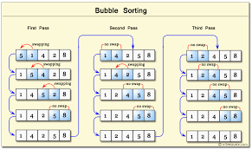

Bubble sort complexity

1. Time Complexity

Case | Time Complexity
Best Case | O(n)
Average Case | O(n²)
Worst Case | O(n²)

- Best Case Complexity - It occurs when there is no sorting required, i.e. the array is already sorted. The best-case time complexity of bubble sort is O(n).
- Average Case Complexity - It occurs when the array elements are in jumbled order that is not properly ascending and not properly descending. The average case time complexity of bubble sort is O(n²).
- Worst Case Complexity - It occurs when the array elements are required to be sorted in reverse order. That means suppose you have to sort the array elements in ascending order, but its elements are in descending order. The worst-case time complexity of bubble sort is O(n²).

Algorithm for optimized bubble sort

- bubbleSort(array)
- n = length(array)
- repeat
- swapped = false
- for i = 1 to n - 1
- if array[i - 1] > array[i], then
- swap(array[i - 1], array[i])
- swapped = true
- end if
- end for
- n = n - 1
- until not swapped
- end bubbleSort

